OCC SPEC Cut down mark scheme
Task 1 – THE PROPOSAL
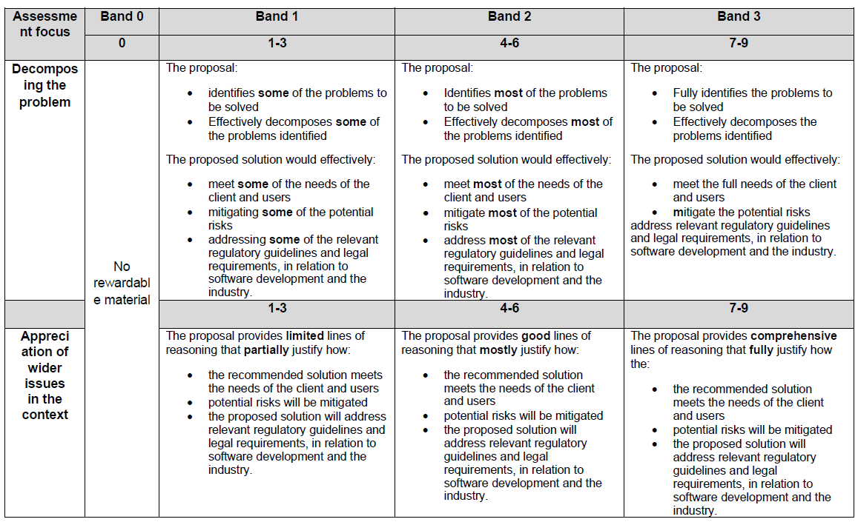
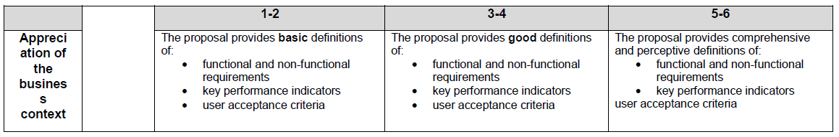

Task 1 - THE DESIGNeffec
Visual Designs
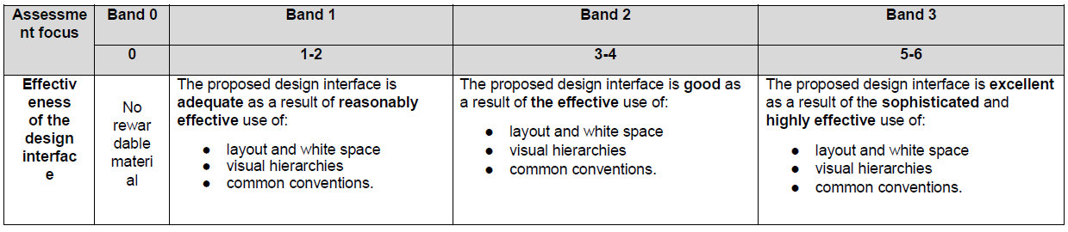

Algorithm Designs
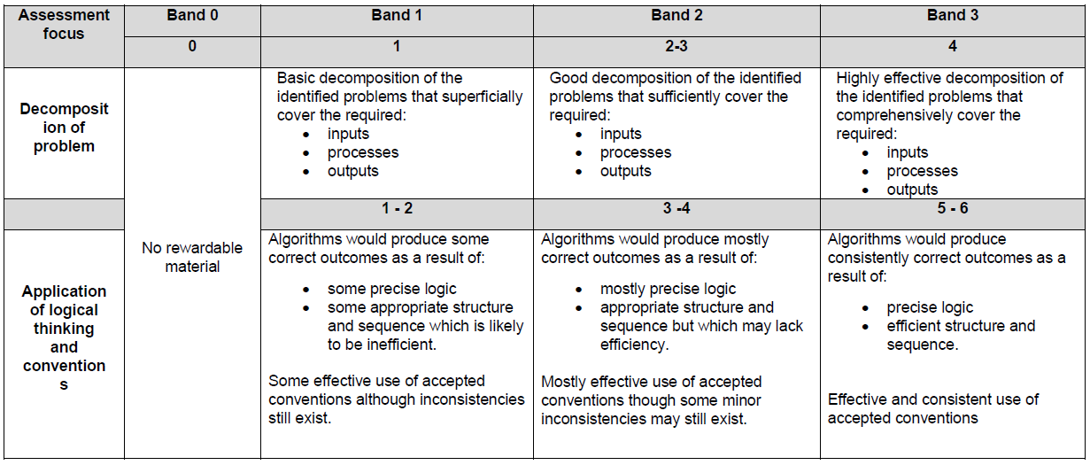

Data Requirements
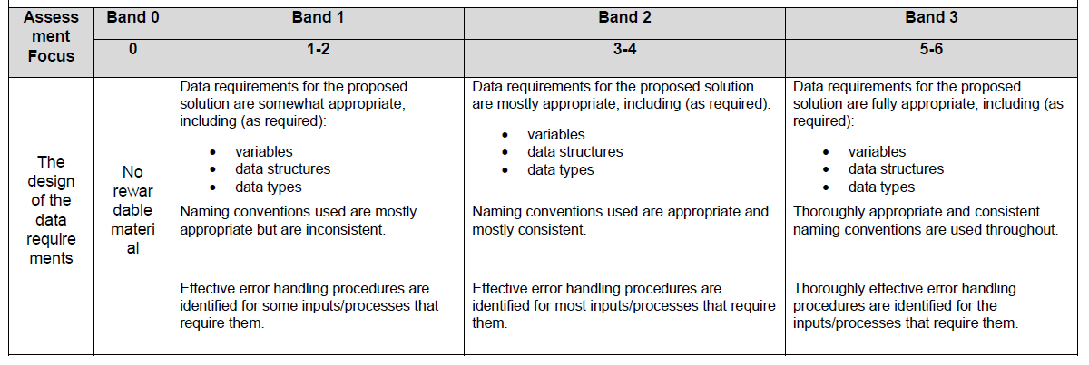
The Test Strategy

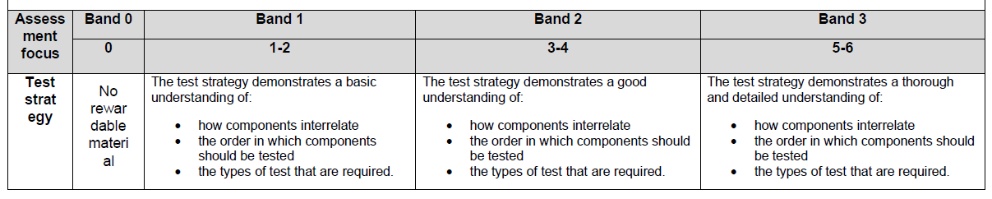
The Design Documentation
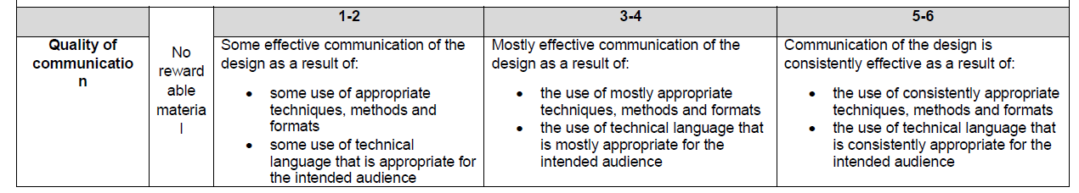

Task 2 - Developing the Solution
The Solution:
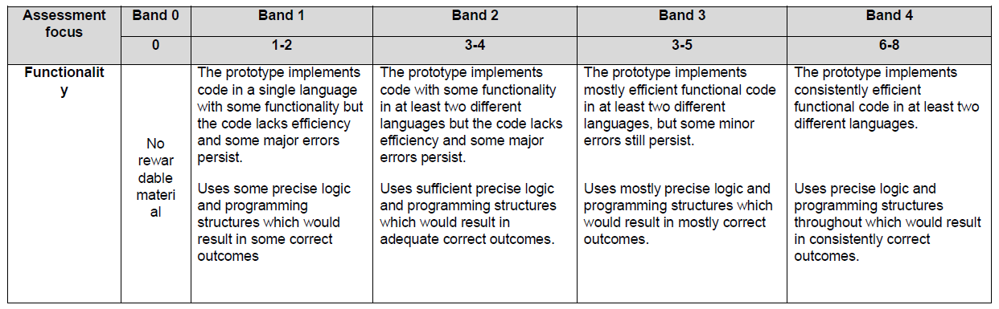
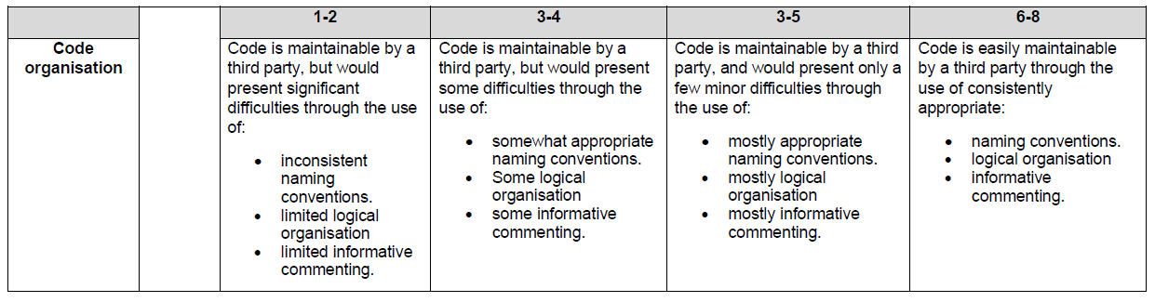

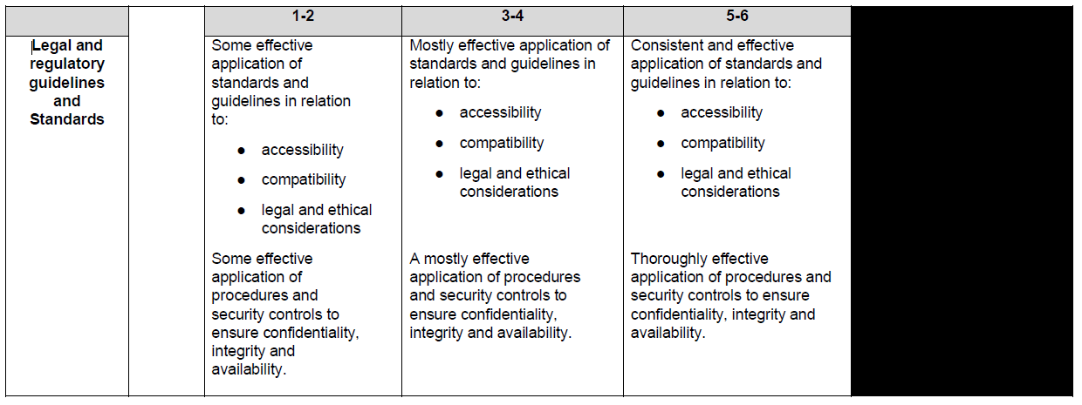

Task 2 - Developing the Solution
Testing
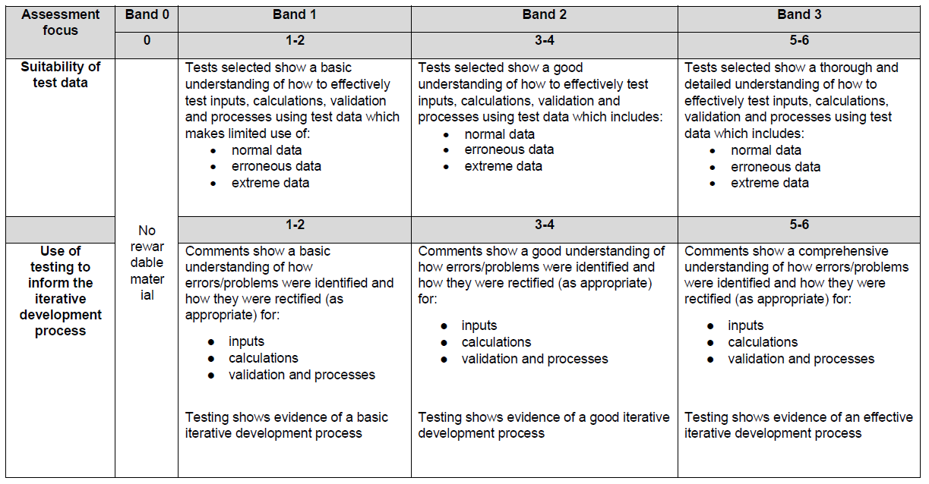

Task 2 - Developing the Solution
Documentation
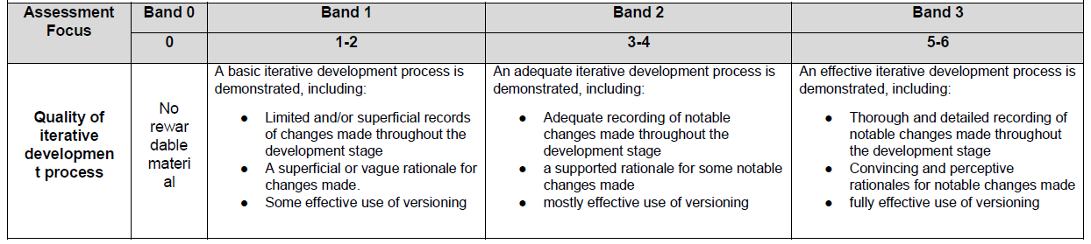
Task 3 Part A Gathering Feedback to inform future development
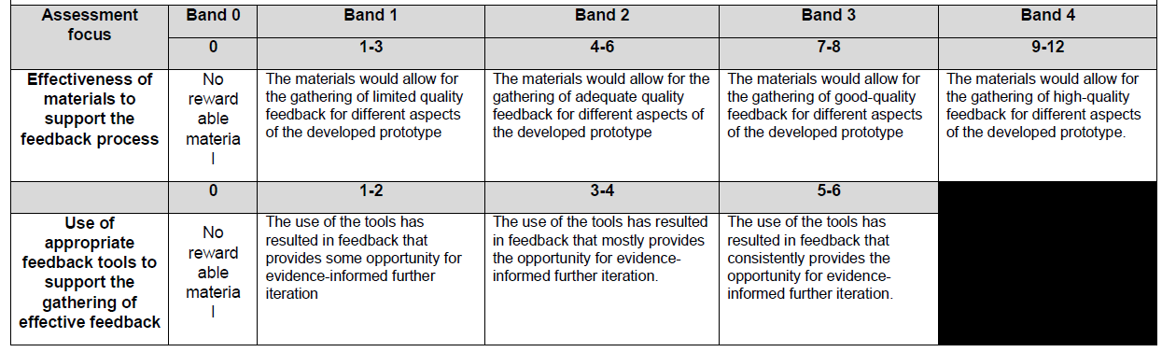
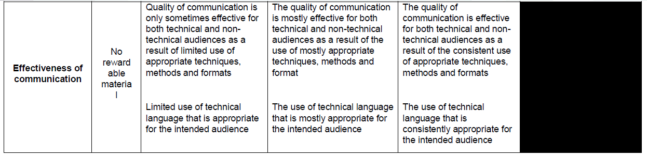

Task 3 B – Evaluating Feedback to inform future development
